Views Assignment:
Base Table:
Emp id unique, Emp Name, Emp Dep, Emp Sal
View:
Emp id, Emp Name, Emp Dep
Try to insert duplicate data for emp id from view
Try to insert or update with unique values in emp id from view
check the view and base table for display of data

#view creation
create view employee_sub as
select empid,empName,empDep
from employee;
select * from employee_sub;

insert into employee_sub
values (2,'Yugan','HR'); ----Not accept dulicate value 2 for empid.

insert into employee_sub
values (8,'Yugan','HR'); ----it will insert the value 8 for empid.

update employee_sub
set empid = 2
Where empid = 4; ------ Not accept duplicate value 2 for empid as 4.

update employee_sub
set empid = 103
Where empid = 3; ------- it will update empid103 where empid as 3.

Output: For view table:

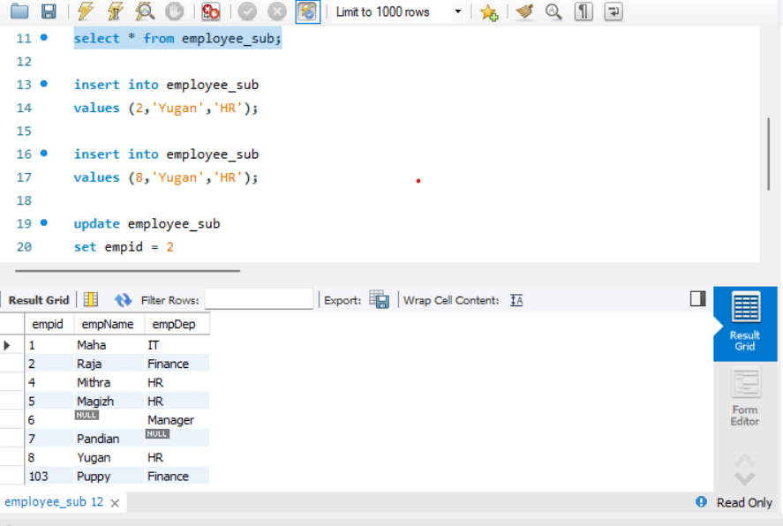

Output: For base table:

